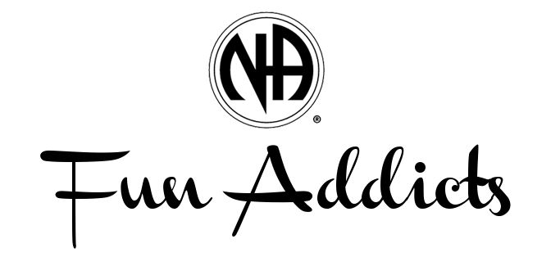
Potluck is Back!
Sunday, March 13th at 6 p.m. upstairs at 301 E. Drake, Fort Collins.
Bring a dish to share or just an appetite. Speaker meeting to follow at 7 p.m. - Sky from FtC and James from Greeley! Future dates are June 12th, Sept 11th, & December 11th.

