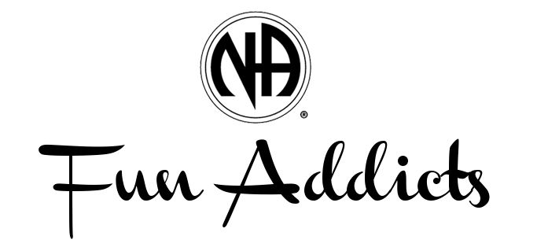
Potluck is Back!
Sunday, March 13th at 6 p.m. upstairs at 301 E. Drake, Fort Collins.
Bring a dish to share or just an appetite. Speaker meeting to follow at 7 p.m. Speakers TBD, one with less than 1 year & another with more than 1 year. Future dates are June 12th, Sept 11th, December 11th.

