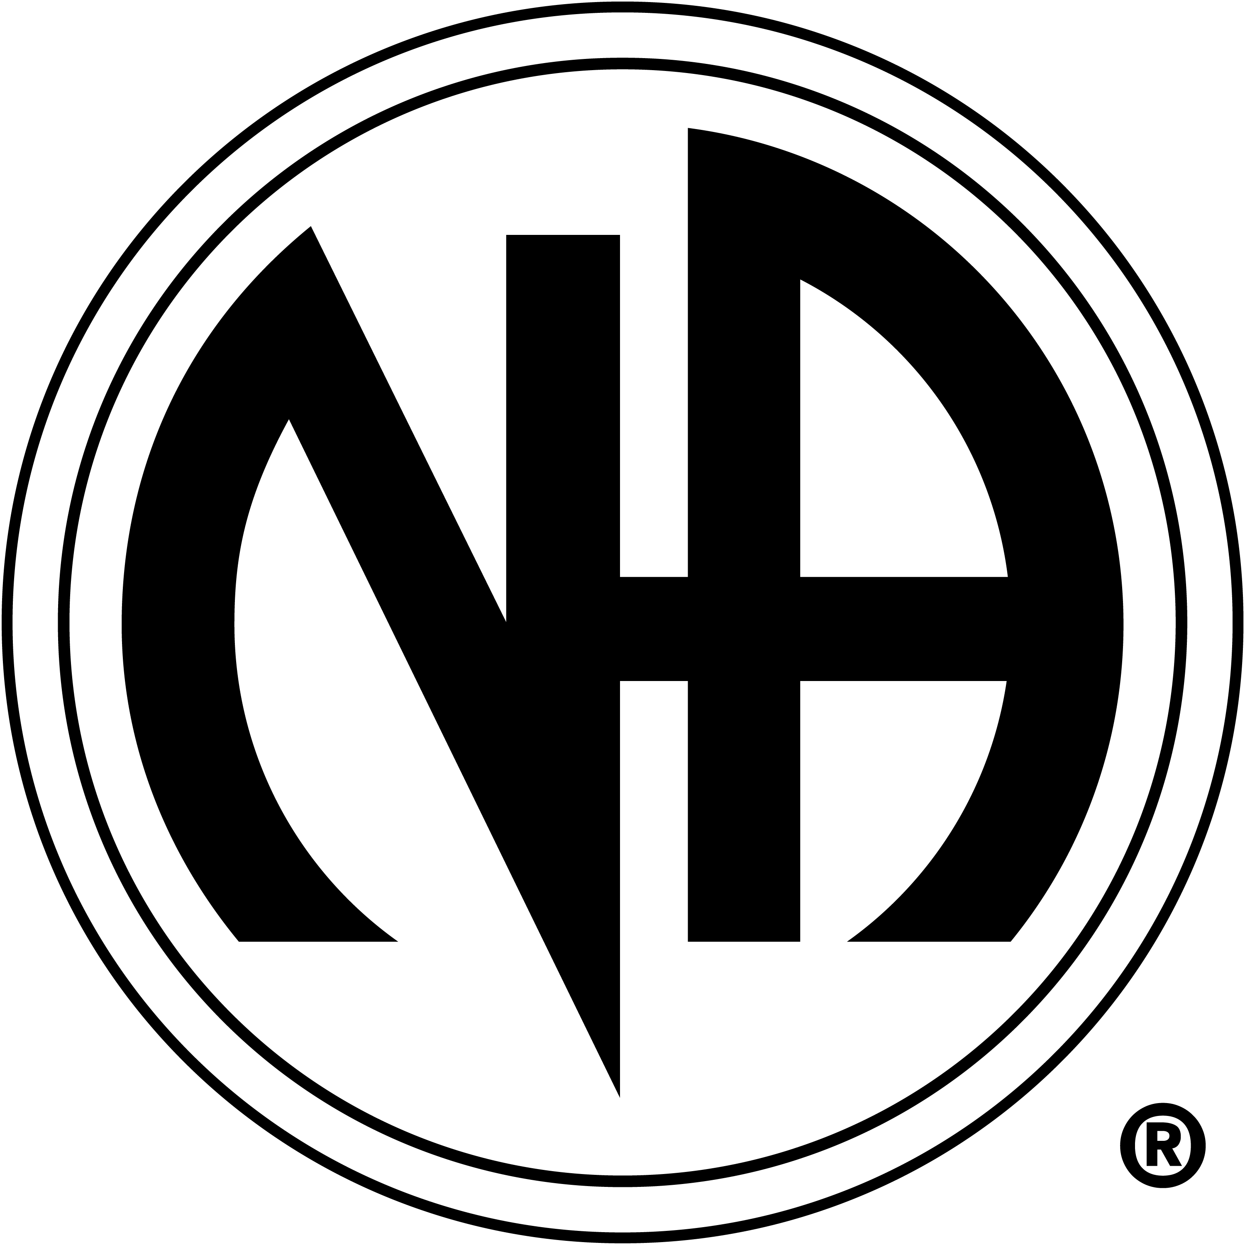

Freed From Insanity invites you to join us on Friday December 24th
For a holiday potluck full of fun and fellowship after the 7pm meeting:
A Turkey and a Ham will be provided please bring a side dish to share. All are welcome.
102 E. 3rd St Loveland Co. 80537

