When at the End of the Road
Memorial Day Picnic
May 30th 2022 1pm

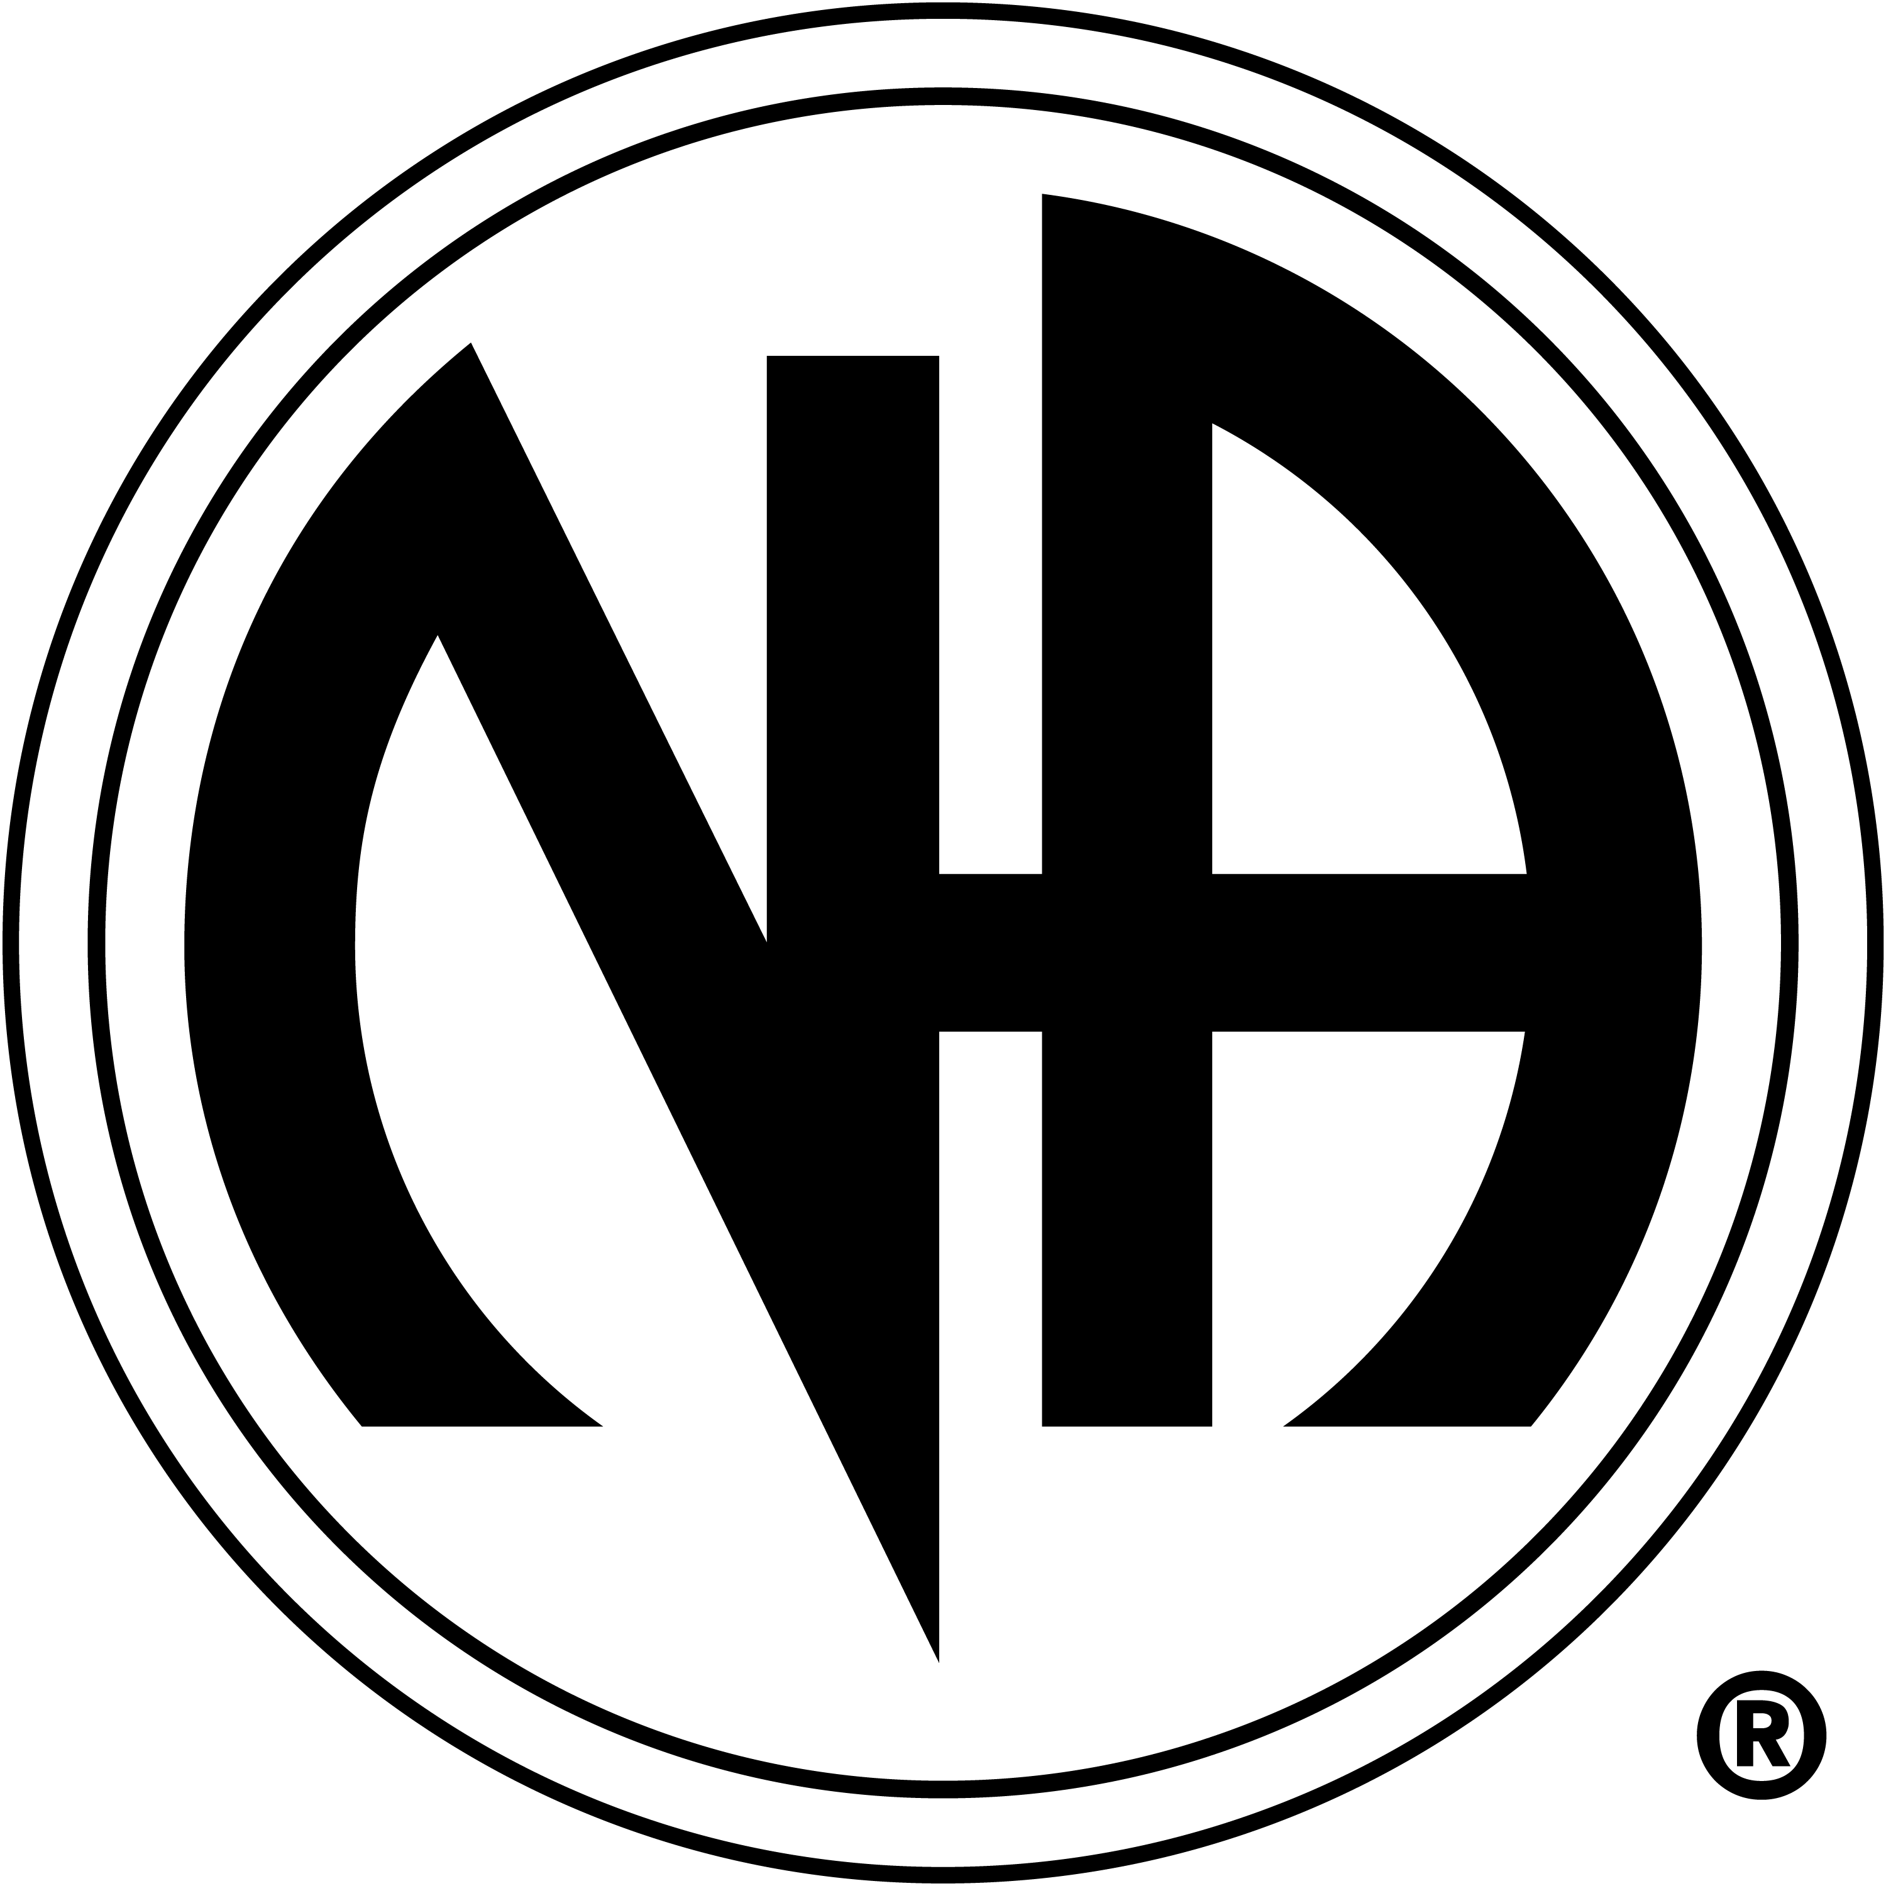

Edora Park, by the horseshoe pits north of EPIC,
1801 Riverside Avenue Fort Collins
Caity and Keith will be sharing their stories
Burgers, Brats, and Hot dogs will be provided
Please bring a dish to share
Suggested Donation $5 per person $8 per couple or family
No addict will be turned away
Please join us for sun, fun, and food in a bun!

